**AIM:**

**SOURCE CODE:**

<!DOCTYPE html>

<html>

<head>

<title>formatting tags</title>

</head>

<body>

<h3>FORMATING TAGS</h3>

<h1>physical tags</h1>

<i>Bapatla Engineering College</i><br>

<b>Bapatla Engineering College</b><br>

<big>Bapatla Engineering College</big><br>

<small>Bapatla Engineering College</small><br>

<u>Bapatla Engineering College</u><br>

bec<sub>Bapatla Engineering College</sub><br>

bec<sub>Bapatla Engineering College</sub>

<H1>logical tags</H1>

<p><abbr title="Bapatla Engineering College">BEC</abbr></p>

<p><dfn title="hypertext mark language">html</dfn></p>

<p><mark>bapatla</mark>engineering college<br>

<p>cse,it,ece,<ins>cs,cs</ins></p>

<P>ece,it,cse<del>,chemical,mech</del>

<p><strong>bapatla engineering college</strong><br>

<p><bdo dir="rtr">HTML</bdo></p>

<p><bdo dir="rtl">HTML</bdo></p>

<p><q>bapatla engineering colege</q><br>

<p>There are two types of errors in java<q>compile time and run time</q></p>

<p>There is an <em>acronym</em> for hypertext markup language</p>

<p><kbd>enter</kbd>key to excute the application</p>

<code>

&lt;!DOCTYPE &gt;

</code>

<p>The <samp> substring()</samp> method returns a new string instance</p>

</body>

</html>

**OUTPUT:**

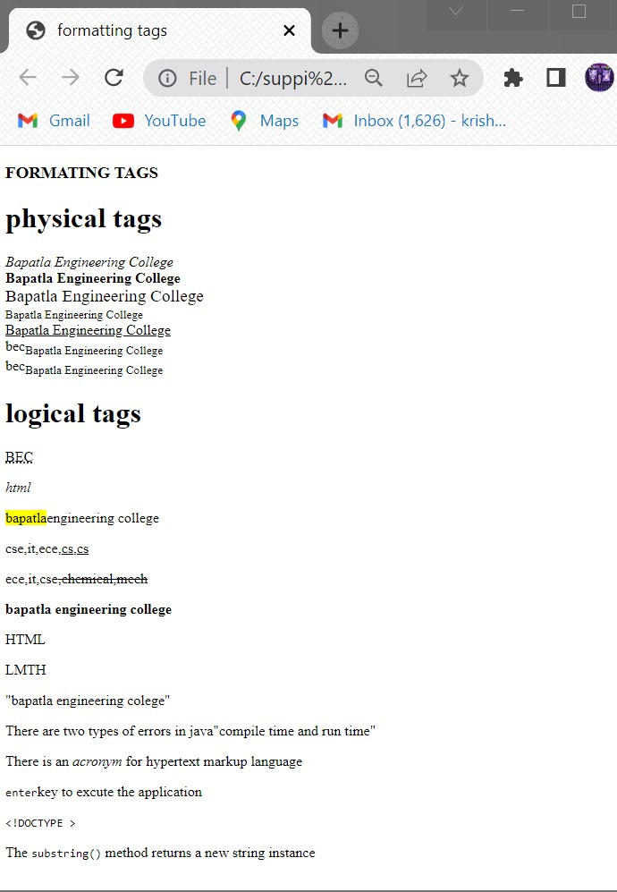

**AIM:**

**SOURCE CODE:**

<!DOCTYPE html>

<html>

<body>

<h2>An unordered HTML List</h2>

<ul>

<li>coffee</li>

<li>tea</li>

<li>milk</li>

</ul>

<h2>An ordered HTML List</h2>

<ol>

<li>coffee</li>

<li>tea</li>

<li>milk</li>

</ol>

<h2> Description list</h2>

<dl>

<dt>Coffee</dt>

<dd>- black hot drink</dd>

<dt>Milk</dt>

<dd>- white cold drink</dd>

</dl>

</body>

</html>

**OUTPUT:**

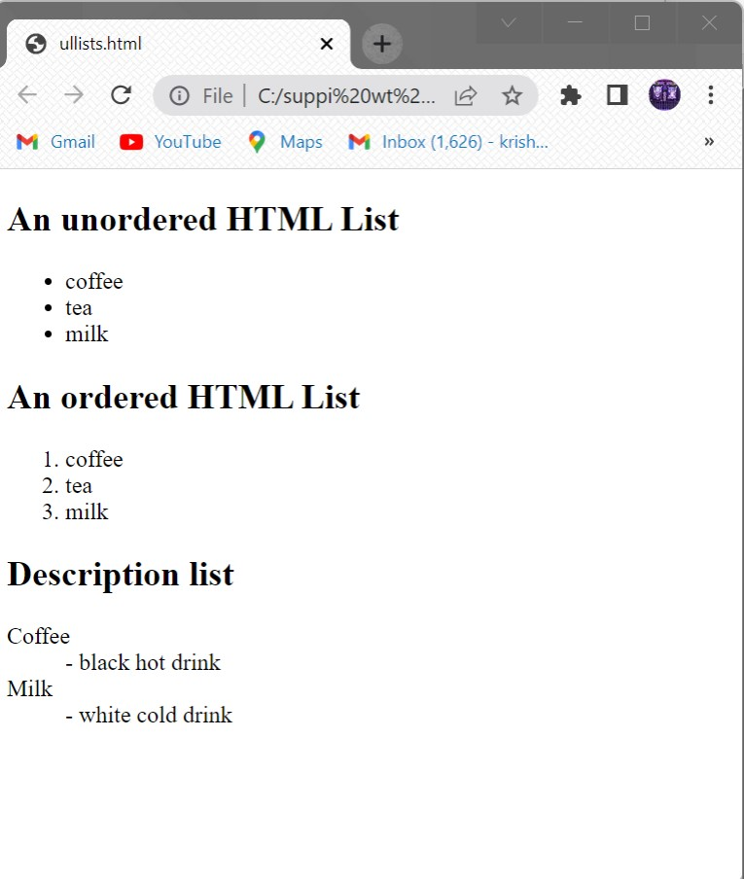

**AIM:**

**SOURCE CODE:**

<!DOCTYPE html>

<html>

<head>

<title>TIME TABLE</title>

</head>

<body>

<div style="width:10%;float:left">

</div>

<h3><center>Bapatla Engineering College::Bapatla</h3>

<h4><center>(Autonoumus)</h4>

<center><h4>Department of Information Technology</h4>

<h4 style="color:red">Class Time Tablefor the <u><mark>A.Y 2021-22,IV Semester</mark></u></h4>

<hr>

<pre>

<h3>

w.e.f: 28-03-20222 class: II B.Tech,IT Section: A Room No: RPLH-03</h3>

</pre>

<table style="border-collapse:collapse" border="10">

<col style="background-color:orange">

<tr style="background-color:orange">

<th>Time<pre>Day</pre></th>

<th>7:30-<pre>8:20</th>

<th>8:20-<pre>9:10</th>

<th>9:10-<pre>10:00</th>

<th rowspan="8"><pre>B</pre><pre>R</pre><pre>E</pre><pre> A </pre><pre>K <pre> </pre></th>

<th>10:30-<pre>11:20</th>

<th>11:20-<pre>12:10</th>

<th>12:10-<pre>1:00</th>

</tr>

<tr>

<td>Mon</td>

<td>PEHV</td>

<td>Python programming</td>

<td>DBMS</td>

<td>P&S</td>

<td>DAA</td>

<td>WT</td>

<tr>

<td>Tue</th>

<td colspan="3"><pre> <-WT/RDBMS-> </pre></td>

<td>DBMS</td>

<td>Python programming</td>

<td>wt</td>

</tr>

<tr>

<td>Wed</td>

<td>DBMS</td>

<td>P&S</td>

<td>DAA</td>

<td colspan="3"><PRE> <-RDBMS/Python prog lab -></PRE></td>

</tr>

<tr>

<td>Thu</td>

<td>PEHV</td>

<td>Python programming</td>

<td>DBMS</td>

<td>P&S</td>

<td>DAA</td>

<td>WT</td>

</tr>

<tr>

<td>Fri</th>

<td colspan="3"><PRE> <-Python prog lab/Wt lab-></PRE></td>

<td>WT</td>

<td>DAA</td>

<td>DBMS</td>

<tr>

<td>Sat</td>

<td>DBMS</td>

<td>DAA</td>

<td>p&s</td>

<td>PEHV</td>

<td>PEHV</td>

<td style=background-color:green> Mentoring</td>

</tr>

</table>

<pre>

<big><mark>Section Coordinator:Mr.k.Suresh Kumar,Asst.professor</b>

</pre>

<table>

<tr style="background-color:orange">

<td>sub:code</td>

<td>sub name</td>

<td>faculty name</td>

<td>sub code</td>

<td>sub name</td>

<td>faculty name</td>

</tr>

<tr>

<td>20IT401</td>

<td>p&s</td>

<td>Mr.pothuraju</td>

<td>20It461</td>

<td>Mr.sk.Mabhasa</td>

<td>Wtlab</td>

</tr>

<tr>

<td>20IT402</td>

<td>wt</td>

<td>Mr.sk.Mabhasa</td>

<td>20It402</td>

<td>RDBMS</td>

<td>Mr.Ravi kumar</td>

</tr>

<tr>

<td>20IT403</td>

<td>DBMS</td>

<td>Mr.Ravi kumar</td>

<td>20It403</td>

<td>python lab</td>

</tr>

<tr>

<td>20IT404</td>

<td>DAA</td>

<td>Mr.sivaram prasad</td>

<td></td>

<td></td>

<td></td>

</tr>

<tr>

<td>MO12</td>

<td>PEHV</td>

<td>Dr.k.srinivasarao</td>

<td></td>

<td></td>

<td></td>

</tr>

</table

<hr>

<pre>

<h3>

w.e.f: 28-03-20222 class: II B.Tech,IT Section: A Room No: RPLH-03</h3>

</pre>

<table style="border-collapse:collapse" border="10">

<col style="background-color:orange">

<tr style="background-color:orange">

<th>Time <pre>Day</th>

<th>7:30-<pre>8:20</th>

<th>8:20-<pre>9:10</th>

<th>9:10-<pre>10:00</th>

<th rowspan="7"><pre> B</pre><pre> R </pre><pre>E</pre><pre> A </pre><pre>K </pre></th>

<th>10:30-<pre>11:20</th>

<th>11:20-<pre>12:10</th>

<th>12:10-<pre>1:00</th>

</tr>

<tr>

<td>Mon</th>

<td colspan="3"><-WT/RDBMS-></td>

<td>DBMS</td>

<td>Python programming</td>

<td>wt</td>

</tr>

<tr>

<td>Tues</td>

<td>P&S</td>

<td>Python programming</td>

<td>DAA</td>

<td>PEHV</td>

<td>DBMS</td>

<td>WT</td>

</tr>

<tr>

<td>Wed</td>

<td>PEHV</td>

<td>Python programming</td>

<td>DBMS</td>

<td>P&S</td>

<td>DAA</td>

<td>WT</td>

</tr>

<tr>

<td>Thu</td>

<td>P&S</td>

<td>WT</td>

<td>DAA</td>

<td colspan="3"><PRE> <-RDBMS/Python prog lab -></PRE></td>

</tr>

<tr>

<td>Wed</td>

<td>PEHV</td>

<td>Python programming</td>

<td>DBMS</td>

<td>P&S</td>

<td>DAA</td>

<td>WT</td>

</tr>

<tr>

<td>Sat</td>

<td>DAA</td>

<td>DBMS</td>

<td>p&s</td>

<td>PEHV</td>

<td>WT</td>

<td style=background-color:green> Mentoring</td>

</tr>

</table>

<pre>

<big><mark>Section Coordinator:Mr.k.Suresh Kumar,Asst.professor</b>

</pre>

<table>

<tr style="background-color:orange">

<td>sub:code</td>

<td>sub name</td>

<td>faculty name</td>

<td>sub code</td>

<td>sub name</td>

<td>faculty name</td>

</tr>

<tr>

<td>20IT401</td>

<td>p&s</td>

<td>Mr.karunakar</td>

<td>20It461</td>

<td>Wtlab</td>

<td>Mr.sk.Mabhasa</td>

</tr>

<tr>

<td>20IT402</td>

<td>wt</td>

<td>Mr.sk.Mabhasa</td>

<td>20It402</td>

<td>RDBMS</td>

<td>Mr.Ravi kumar</td>

</tr>

<tr>

<td>20IT403</td>

<td>DBMS</td>

<td>Mr.Ravi kumar</td>

<td>20It403</td>

<td>python lab</td>

<td>Mr.k.Prasanth</td>

</tr>

<tr>

<td>20IT404</td>

<td>DAA</td>

<td>Mr.Ratna prakash</td>

<td></td>

<td></td>

<td></td>

</tr>

<tr>

<td>MO12</td>

<td>PEHV</td>

<td>Dr.k.srinivasarao</td>

<td></td>

<td></td>

<td></td>

</tr>

</table><pre>

<pre>

<big> HOD PRINCIPAL </big>

</pre>

**OUTPUT:**

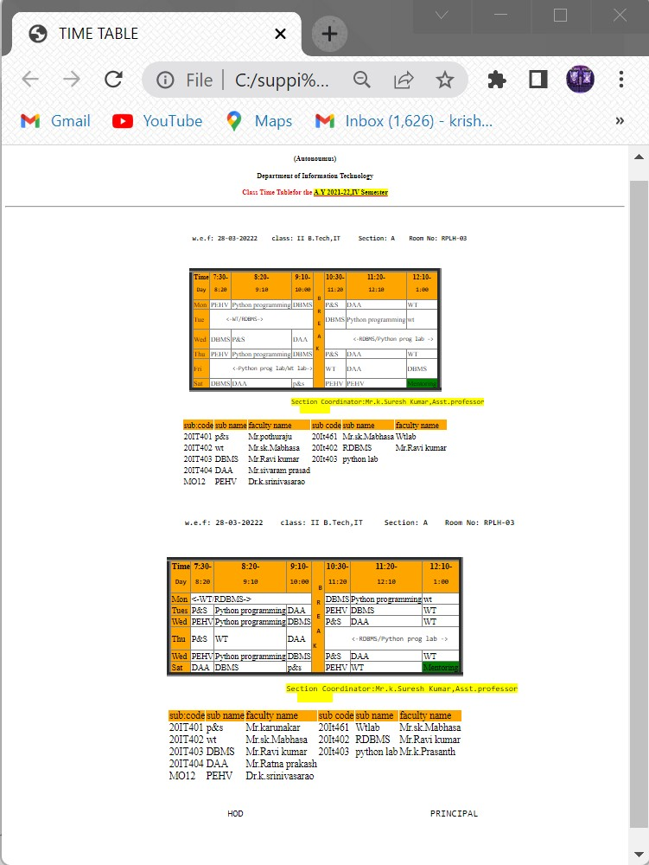

**AIM:**

**SOURCE CODE:**

<!DOCTYPE html>

<html>

<body>

<title> hyper link</title>

<p>click here to open <a href="http://www.geeksforgeek.com" target="_blank">geeks for geek webpage</a></p>

<p> click here to open<a href=studentdetails.html" target="_top">details</a></p>

<p><a href="http://www.becbapatla.ac.in" target="_self"><img src="beclogo.png" height="200" width="200"></a></p>

<a id ="top"></a>

<h1>top of the page</h1>

<a href="#bottom">click to bottom</a><br>

<a href="#middle">click to middle</a>

<p>click here </p>

<p>click here </p>

<p>click here </p>

<p>click here </p>

<p>click here </p>

<p>click here </p>

<p>click here </p>

<p>click here </p>

<p>click here </p>

<p>click here </p>

<p>click here </p>

<a id ="middle"></a>

<h1> middle of page</h1>

<a href="#top">click to top</a><br>

<a href="#bottom">click to bottom</a>

<p>click here </p>

<p>click here </p>

<p>click here </p>

<p>click here </p>

<p>click here </p>

<p>click here </p>

<p>click here </p>

<p>click here </p>

<p>click here </p>

<p>click here </p>

<p>click here </p>

<p>click here </p>

<a id ="bottom"></a>

<h1> bottom of page</h1>

<a href="#top">click to top</a><br>

<a href="#middle">click to middle</a>

</body>

</html>

**OUTPUT:**

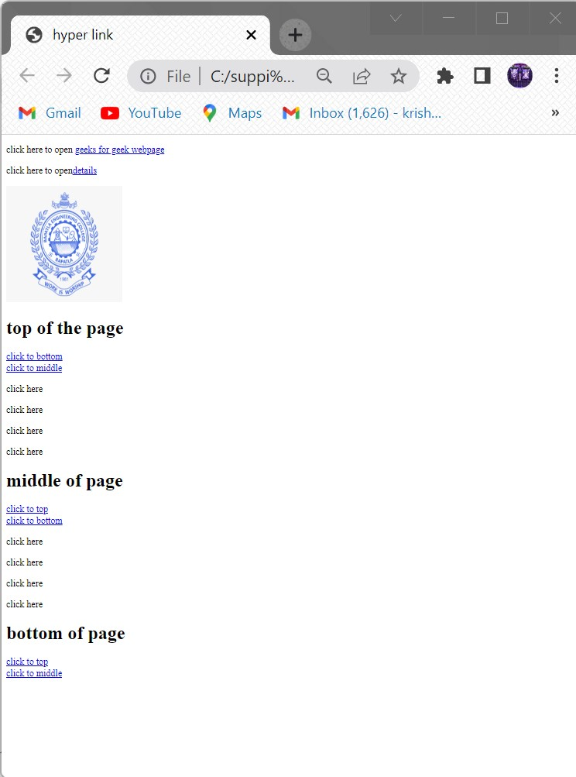

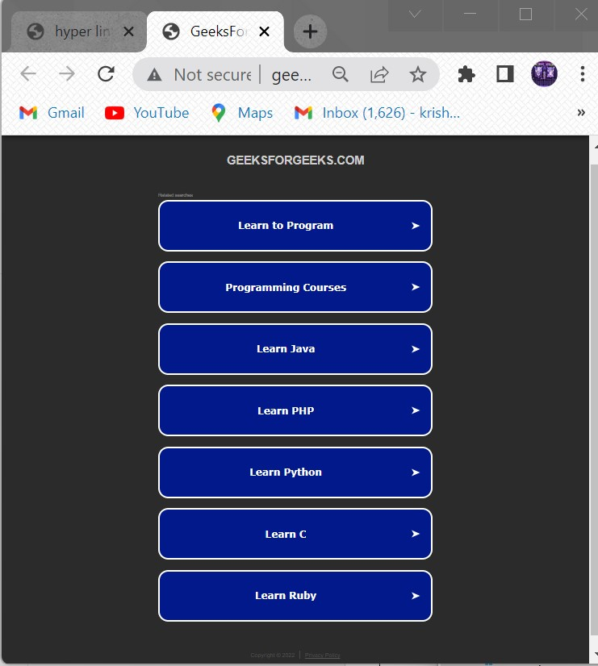

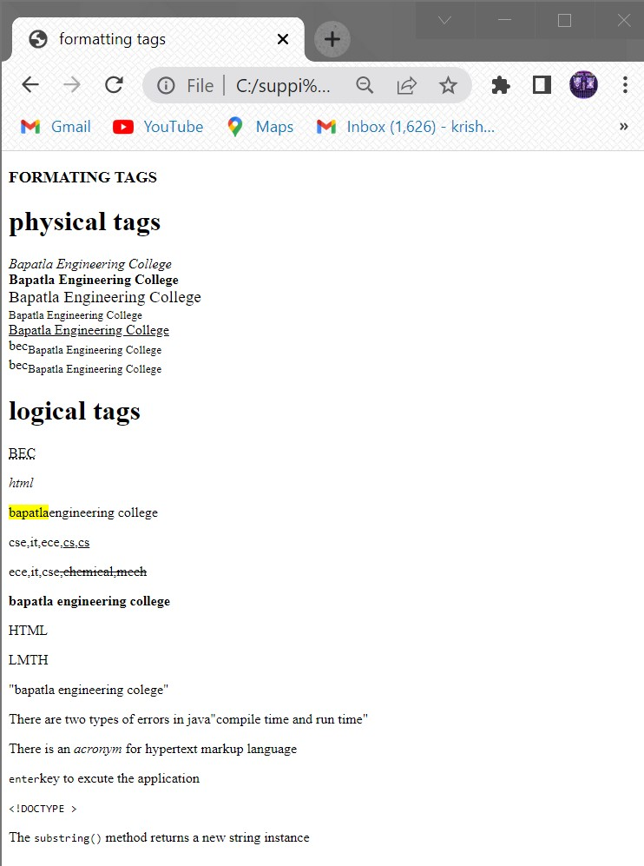

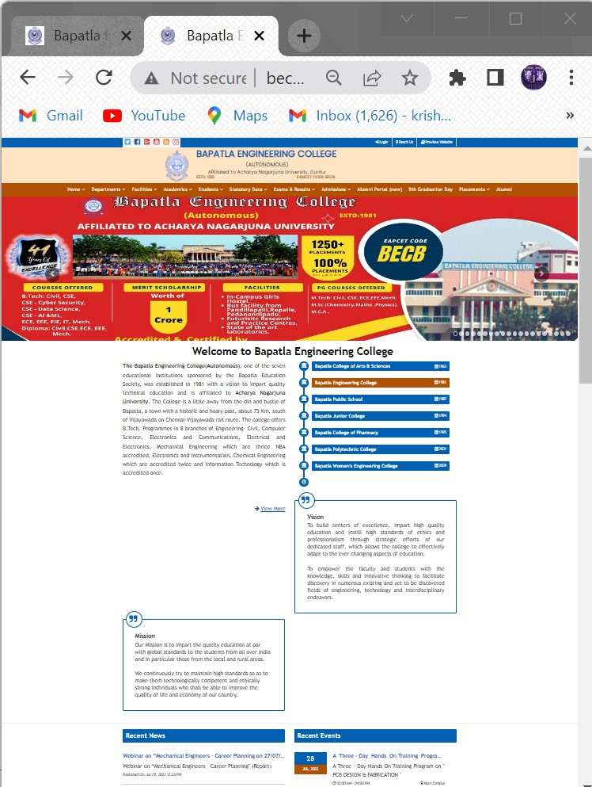

**AIM:**

**SOURCE CODE:**

<!DOCTYPE html>

<html>

<head>

<title>frames</title>

</head>

<frameset rows="20%,20%,40%,20%">

<frame name="header"/>

<frame src="" name="header"/>

<frameset cols="25%,75%">

<frame src="nav.html" name="aside"/>

<frame src="" name="section"/>

</frameset>

<frame src="" name="footer"/>

</frameset>

<html>

**Nav.htmlfile:**

<!DOCTYPE html>

<html>

<head>

<title>frames</title>

</head>

<body>

<center><h1>NAVIGATION</h1>

<nav>

<a id="top"></a>

<a href="#bottom"><img src="down.png" width=150" height="80"></a><br>

Bapatla Engineering College<br>

Bapatla Engineering College<br>

Bapatla Engineering College<br>

Bapatla Engineering College<br>

<a id="bottom"></a>

<a href="#top"><img src="top.jpg" width="80" height="80">bottomimage</a>

</nav>

</BODY>

</HTML>

**OUTPUT:**

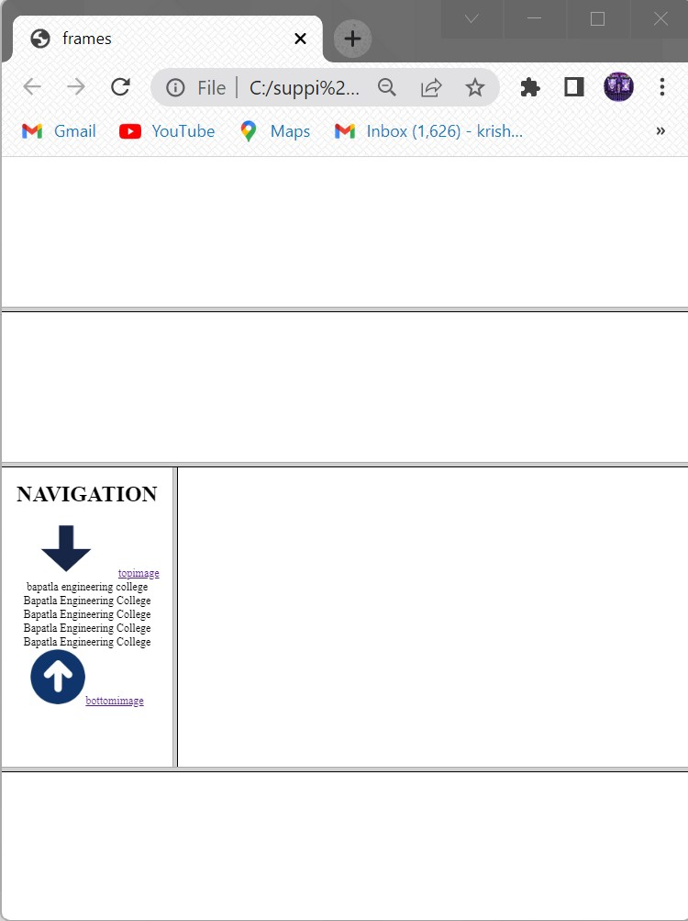

**AIM:**

**SOURCE CODE:**

<!doctype html>

<html>

<head>

<title>image map</title>

</head>

<body>

<h1>working with image map</h1>

<img src="imagemap.jpg" width="500" height="600" alt="india map" usemap="#india">

<map name="india">

<area shape="circle" coords="200,400,50" href="https://psc.ap.gov.in/">

<area shape="rect" coords="150,70,80,150" href="https://registration.telangana.gov.in/">

<area shape="crcle" coords="300,200,150" href="https://jammu.nic.in/">

<area shape="rect" coords="150,70,80,150" href="https://registration.meghalaya.gov.in/">

<area shape="crcle" coords="300,200,150" href="https://gujarat.nic.in/">

<area shape="rect" coords="150,70,80,150" href="https://registration.maharashtra.gov.in/">

<area shape="rect" coords="150,70,80,150" href="https://registration.bihar.gov.in/">

<area shape="crcle" coords="300,200,150" href="https://rajasthan.nic.in/">

<area shape="crcle" coords="300,200,150" href="https://kerala.nic.in/">

</body>

</html>

**OUTPUT:**

**AIM:**

**SOURCE CODE:**

<!DOCTYPE HTML>

<html>

<head>

<title>forms application</title>

</head>

<body style="background-color:cyan">

<form>

<center><table border="1px"width="1000" style="text-align:center">

<tr>

<td><h1>Student Registration Form</h1>

</td>

</tr>

</table></center><br><br>

<label>Name :</label>

<input type="text" placeholder="Enter ful name" size="70"><br/><br/>

<label>Father's Name :</label>

<input type="text" size="70"><br/><br>

<label>Mother's Name :</label>

<input type="text" size="70"><br/><br>

<label>Phone Number :</label>

<input type="number" placeholder="017*******" size="70"><br/><br>

<label>Email :</label>

<input type="email" placeholder="sample@example.com" size="70"><br/><br>

<label>Gender : :</label>

<input type="radio" value="Male"name="gender">Male

<input type="radio" value="Female"name="gender">Female

<input type="radio" value="Other"name="gender">Other<br/><br>

<label>Date of birth</label>

<input type="text"size="10">-

<input type="text"size="10">-

<input type="text"size="10">(dd-mm-yy)<br><br

<label>Address :</label>

<textarea rows="1"cols="100">

Street- House-Road

</textarea><br><br>

<label>Blood Group: :</label>

<select >

<option>select</option>

<option>A</option>

<option>A+</option>

<option>B</option>

<option>B+</option>

<option>AB+</option>

<option>AB-</option>

<option>O-</option>

<option>O+</option>

</select><br/><br>

<label>Department :</label>

<label> :</label>

<input type="radio" value="CSE"name="department">CSE

<input type="radio" value="EEE"name="department">EEE

<input type="radio" value="BBA"name="department">BBA<br/><br>

<label>Course</label>

<input type="checkbox"value="c">c

<input type="checkbox"value="c++">c++

<input type="checkbox"value="java">java

<input type="checkbox"value="AI">AI

<input type="checkbox"value="Machine learning">Machine learning

<input type="checkbox"value="Robotics">Robotics<br><br>

<label>Photo :</label>

<input type="file"><br><br><br><br>

<a href="p1.html">Submit</a>

</body>

</html>

**OUTPUT:**

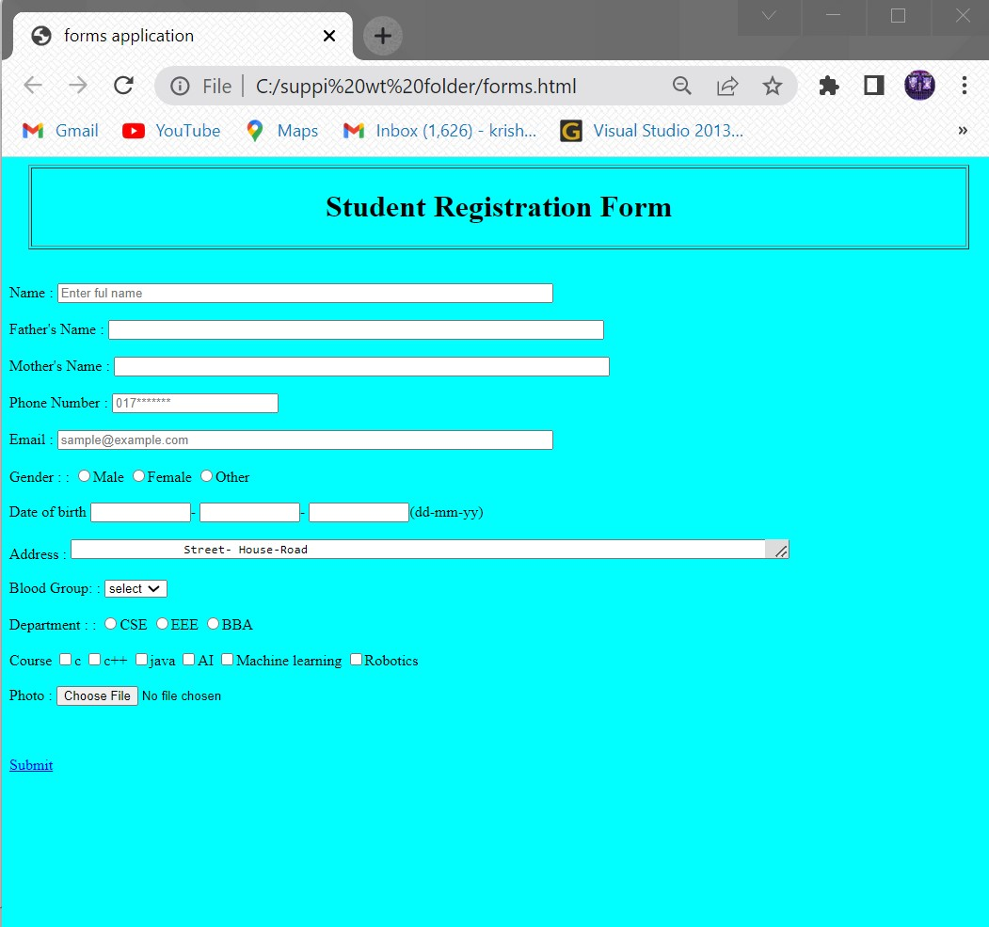

**AIM:**

**SOURCECODE:**

<!DOCTYPE html>

<html>

<head>

<title>FORM</title>

</head>

<body>

<form action="https://www.w3schools.com/tags/tag_legend.ASP">

<fieldset style="background:yellow;border-color:red">

<legend style="background:blue;color:white">Details</legend>

<label>NAME:</label>&nbsp&nbsp&nbsp&nbsp

<input type="text" name="NAME:"><br><br><br>

<label>Father Name:</label>

<input type="text" name="Father Name:"><br><br><br>

<label>Address:</label>

<textarea name="Address:"></textarea><br><br><br>

<label>BloodGroup:</label>

<select>

<option>select</option>

<option>A+</option>

<option>B+</option>

<option>AB+</option>

<option>A-</option>

<option>B-</option>

<option>AB-</option>

</select><br>

<label> Colleges:</label>

<select>

<optgroup label="Engineering colleges">

<option>BEC</option>

<option>GEC</option>

<option>LBRCE</option>

</optgroup>

<optgroup label="Inter colleges">

<option>Inter colleges</option>

<option>Chaithanya college</option>

<option>Narayana college</option>

</optgroup>

</select><br><br>

<input type="submit" >

</fieldset>

</form>

</body>

</html>

**OUTPUT:**

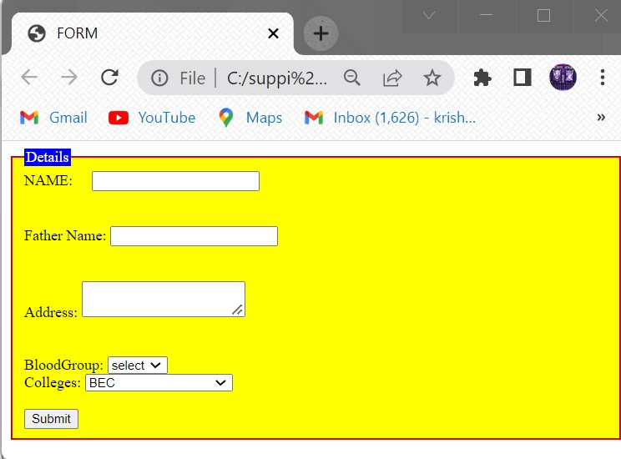

**AIM:**

**SOURCECODE:**

<!doctype html>

<html>

<head>

<title>inline</title>

<body style="color:red; background-color:pink; font-family:sans-serif">

<h1 style="font-size:18pt">The fontsize of this heading is 18pt</h1>

<p style="font-size:12pt">The fontsize of this paragraph is 12pt</p>

<h1 style=" color:red; background-color:yellow font-size:18pt">The fontsize of this heading is 18pt</h1>

<p style="color:#ffff00; font-size:12pt">The fontsize of this paragraph is 18pt</p>

</body>

</html>

**OUTPUT:**

**AIM:**

**SOURCECODE:’**

<!DOCTYPE HTML>

<HEAD>

<TITLE>CSS Example </TITLE>

<STYLE>

*{margin: 0;}

body {

color:red;

background-color:lightgrey;

font-family: sans-serif;}

h1{font-size:18pt}

p{font-size:12pt}

</STYLE>

</HEAD>

<BODY>

<H1>The font size of this heading is 18pt</H1>

<P>The font size of this paragraph is 12pt</P><BR/><BR/>

<H1 style="color:#ff0000;background-color:#ffff00;font-family: Ariel;">

The font size of this heading is 18pt </H1>

<P style="color:yellow; font-size:10pt">The font size of this paragraph is 12pt</P>

</BODY>

</HTML>

**OUTPUT:**

**AIM:**

**SOURCECODE:**

<!DOCTYPE HTML>

<HEAD>

<TITLE>CSS Example </TITLE>

<LINK rel="stylesheet" type="text/css" href="example.css"/>

</HEAD>

<BODY>

<H1>The font size of this heading is 18pt</H1>

<P>The font size of this paragraph is 12pt</P>

<TABLE>

<TR>

<TH>living being</TH>

<TH>shelter</TH>

</TR>

<TR>

<TD class="code">Lion</TD>

<TD>Lion lives in the den</TD>

</TR>

<TR>

<TD class="code">Man</td>

<TD>Man lives in house</TD>

</TR>

<TR>

<TD class="code">Fish</TD>

<TD>Fish lives in water</TD>

</TR>

<TR>

<TD class="code">Bird</TD>

<TD>Bird lives in nest</TD>

</TR>

</TABLE>

</BODY>

</HTML>

**Example.css:**

*{margin: 0;}

body

{

color:#000000;

background-color:#00ff00;

font-family: sans-serif;

}

h1{font-size:18pt}

p{font-size:12pt}

table

{

background-color:#efefef;

border-style:solid;

border-width:2px;

border-color:#999900;

}

th

{

background-color:#cccc00;

font-weight:bold;

padding:3px;

}

td{padding:3px}

td.code

{

font-family: serif;

font-weight:bold

}

**OUTPUT:**

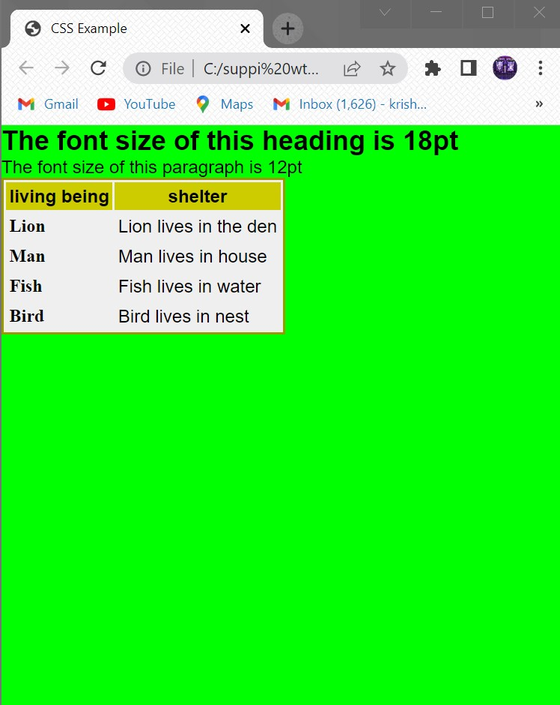

**AIM:**

**SOURCECODE:**

<!DOCTYPE HTML>

<HEAD>

<TITLE>CSS Example </TITLE>

<STYLE TYPE="text/css">

@import url("example.css");

P {color:blue}

</STYLE>

</HEAD>

<BODY>

<H1>The font size of this heading is 18pt</H1>

<P>The font size of this paragraph is 12pt</P>

<TABLE>

<TR>

<TH>living being</TH>

<TH>shelter</TH>

</TR>

<TR>

<TD class="code">Lion</TD>

<TD>Lion lives in the den</TD>

</TR>

<TR>

<TD class="code">Man</TD>

<TD>Man lives in house</TD>

</TR>

<TR>

<TD class="code">Fish</TD>

<TD>Fish lives in water</TD>

</TR>

<TR>

<TD class="code">Bird</TD>

<TD>Bird lives in nest</TD>

</TR>

</TABLE>

</BODY>

</HTML>

**Example.css:**

*{margin: 0;}

body

{

color:#000000;

background-color:#00ff00;

font-family: sans-serif;

}

h1{font-size:18pt}

p{font-size:12pt}

table

{

background-color:#efefef;

border-style:solid;

border-width:2px;

border-color:#999900;

}

th

{

background-color:#cccc00;

font-weight:bold;

padding:3px;

}

td{padding:3px}

td.code

{

font-family: serif;

font-weight:bold;

}

**OUTPUT:**

